**Class Lab 9**

Use two images for each operation to do the following operations and write down their advantages and disadvantages and explain your results:

1. **Roberts (headCT_Vandy, building_original, noisy_fingerprint):**

**Algorithm:**

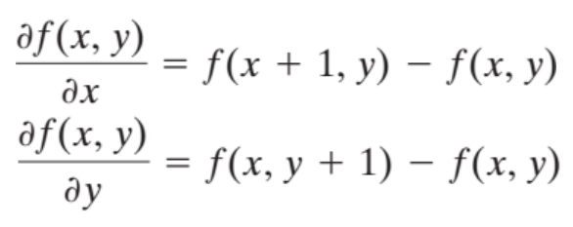

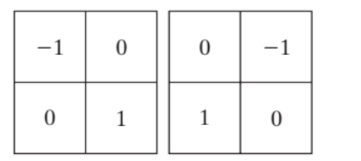

**Results (including pictures):**

Result of processing “headCT_Vandy.pgm”:

Source Image:

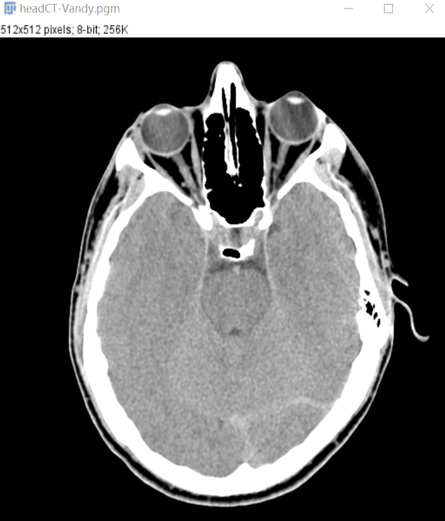

Result after Roberts:

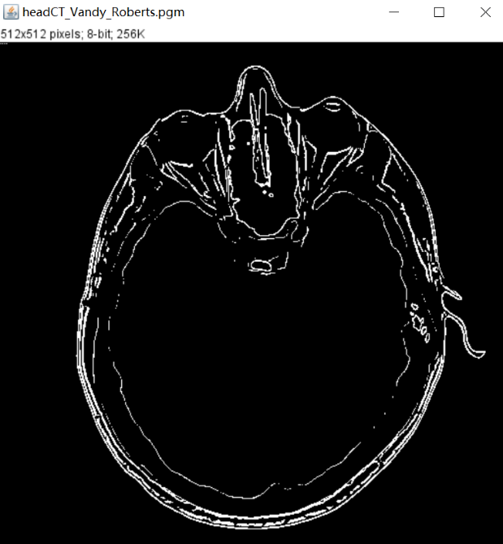

Result of processing “building_original.pgm”:

Source Image:



Result after Roberts:

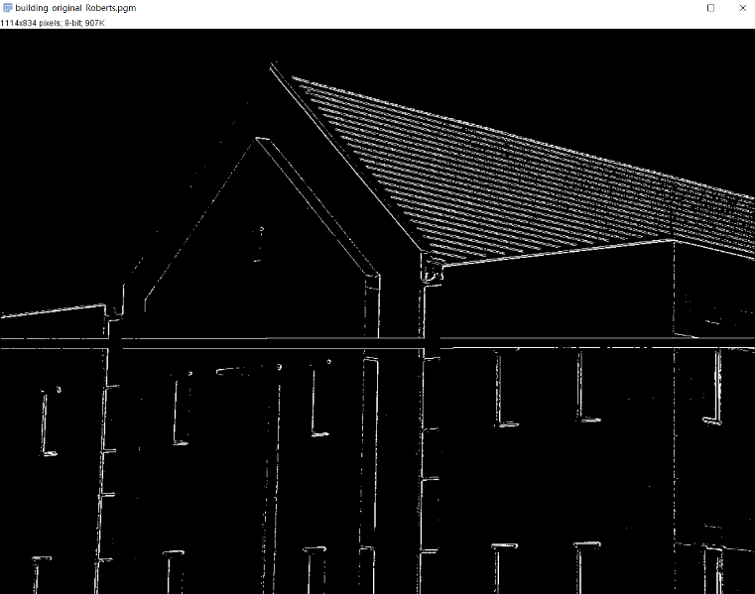

Result of processing “noisy_fingerprint.pgm”:

Source Image:

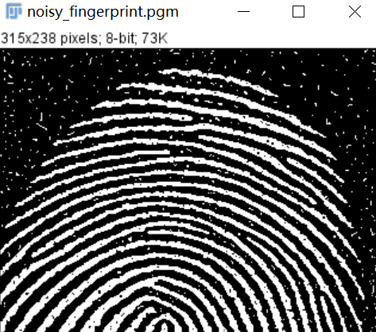

Result after Roberts:

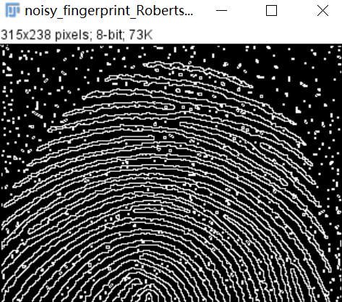

**Discussion:**

As a first-order differential operator, Robert is simple, requires little computation, and is sensitive to details. The role of the operator for edge detection is to provide edge candidate points. Compared with other 3x3 operators, the Robert operator can provide relatively finer edges without post-processing.

**Codes:**

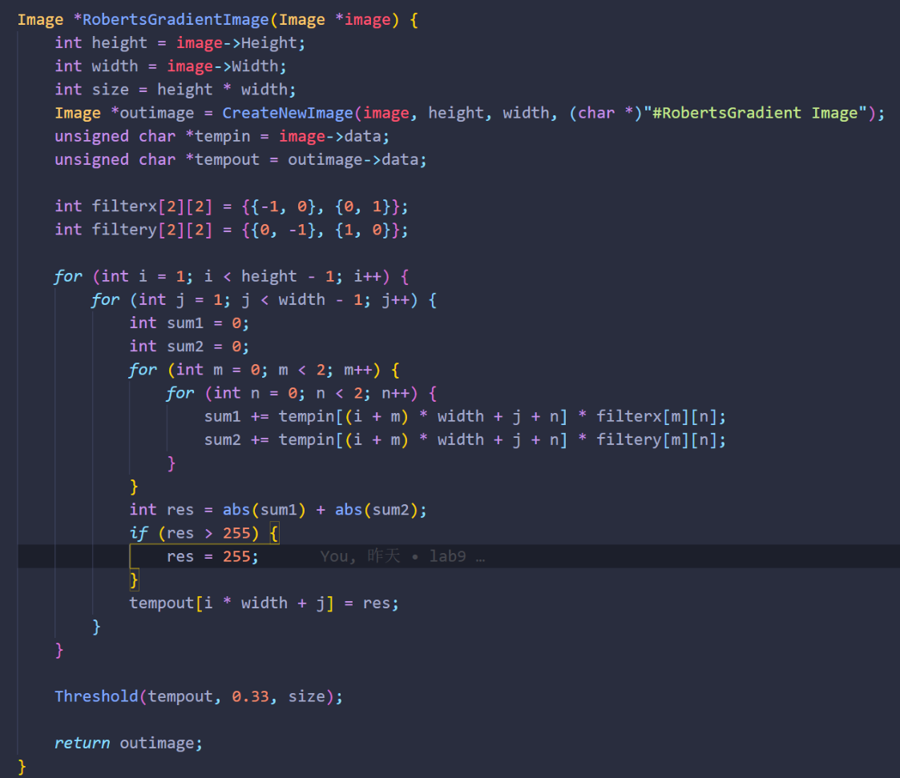

1. **Prewitt (headCT_Vandy, building_original, noisy_fingerprint):**

**Algorithm:**



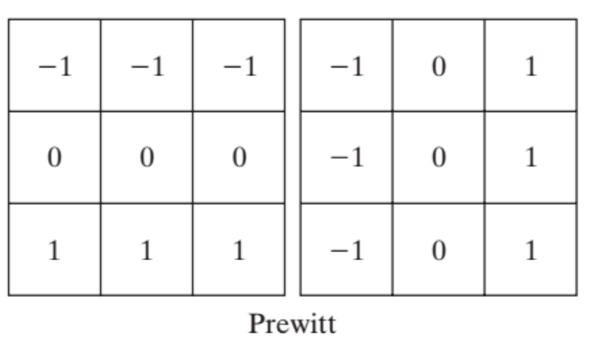

**Results (including pictures):**

Result of processing “headCT_Vandy.pgm”:

Source Image:



Result after Prewitt:

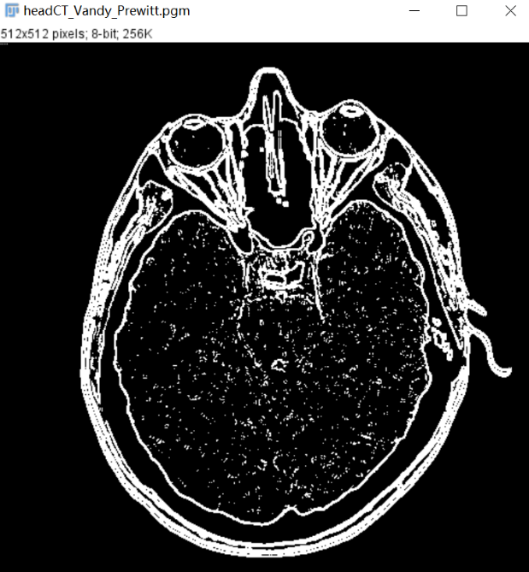

Result of processing “building_original.pgm”:

Source Image:



Result after Prewitt:

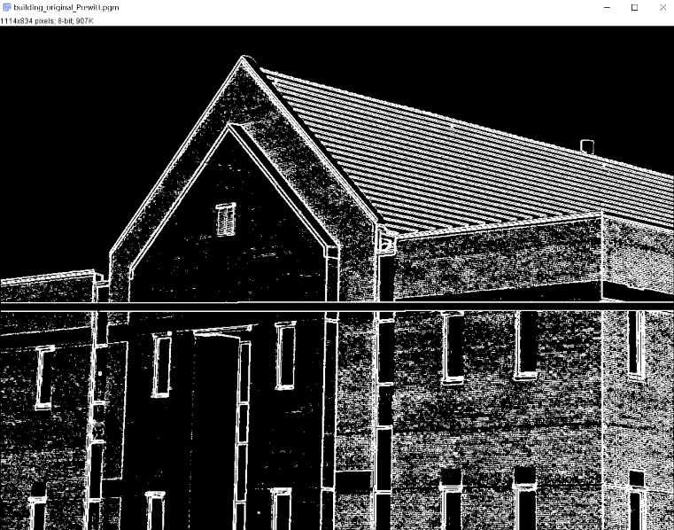

Result of processing “noisy_fingerprint.pgm”:

Source Image:



Result after Prewitt:

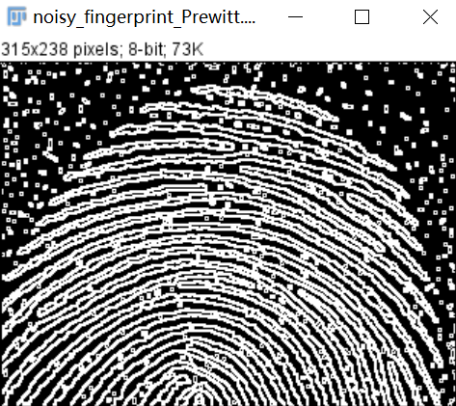

**Discussion:**

Since the Prewitt operator uses a 3x3 template to calculate the pixel values in the region, while the Robert operator's template is 2x2, the edge detection results of the Prewitt operator are more obvious than those of the Robert operator in both the horizontal and vertical directions. Prewitt operator is suitable for identifying images with more noise and grayscale gradient

**Codes:**

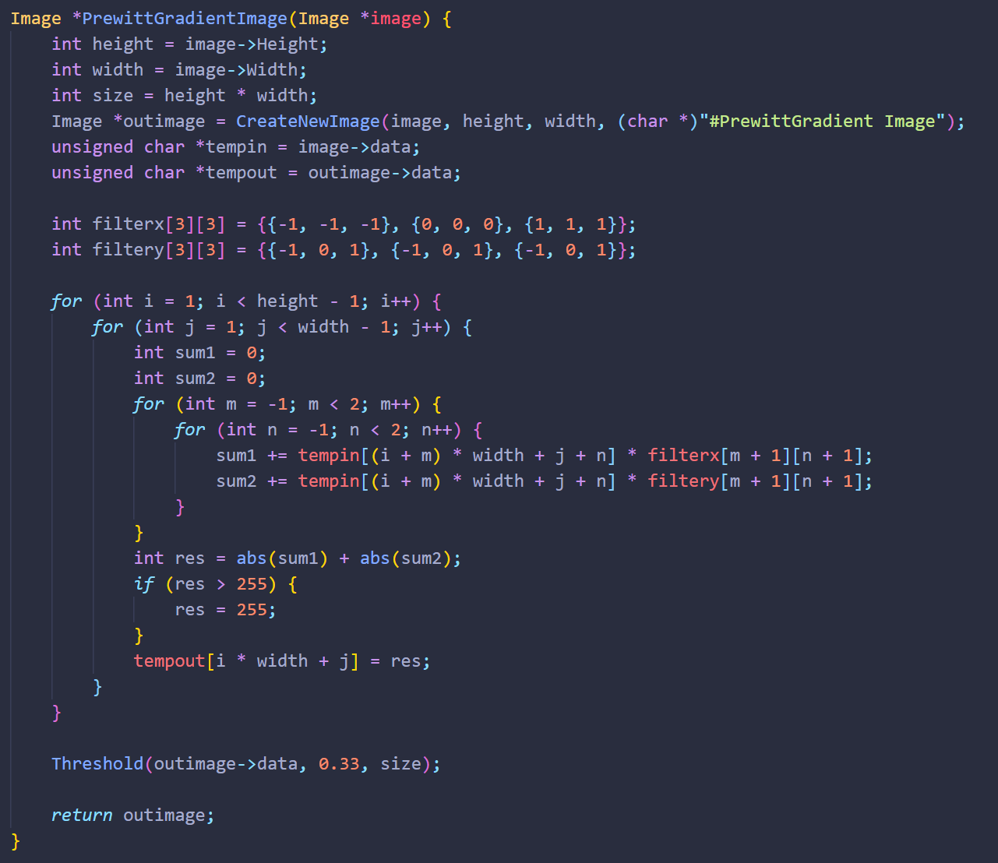

1. **Soble (headCT_Vandy, building_original, noisy_fingerprint):**

**Algorithm:**



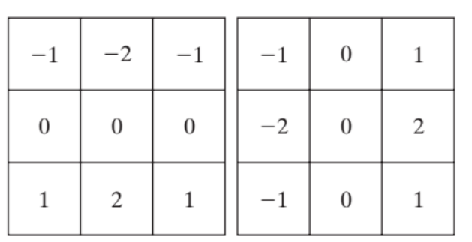

**Results (including pictures):**

Result of processing “building_original.pgm”:

Source Image:



Result after Soble:

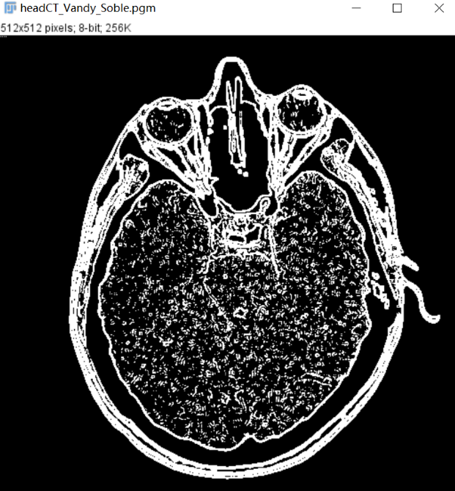

Result of processing “headCT_Vandy.pgm”:

Source Image:



Result after Soble:

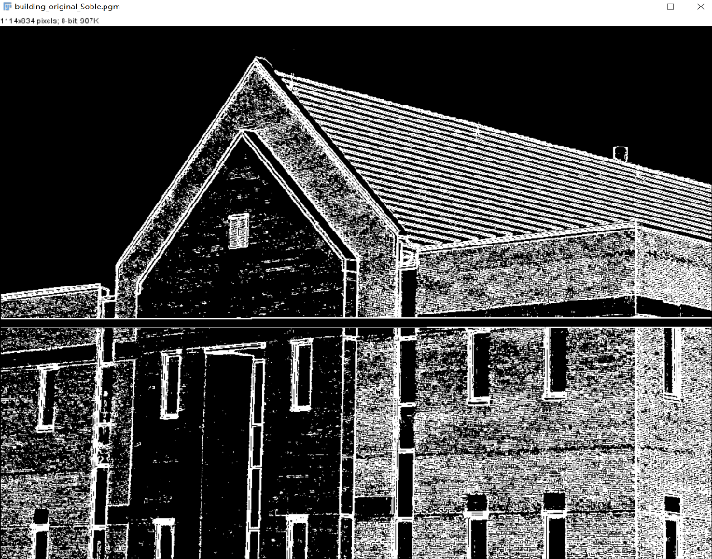

Result of processing “noisy_fingerprint.pgm”:

Source Image:



Result after Soble:

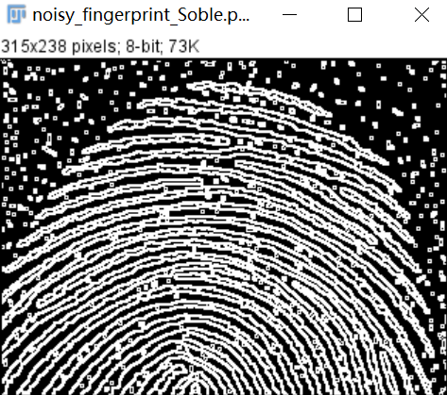

**Discussion:**

Sobel operator not only produces better detection effect, but also has a smooth suppression effect on noise, but the obtained edge is thicker and may appear false edge. Compared with the Prewitt operator, the Sobel operator has weighted the influence of the position of the pixel, which can reduce the blurring degree of the edge, so the effect is better.

**Codes:**

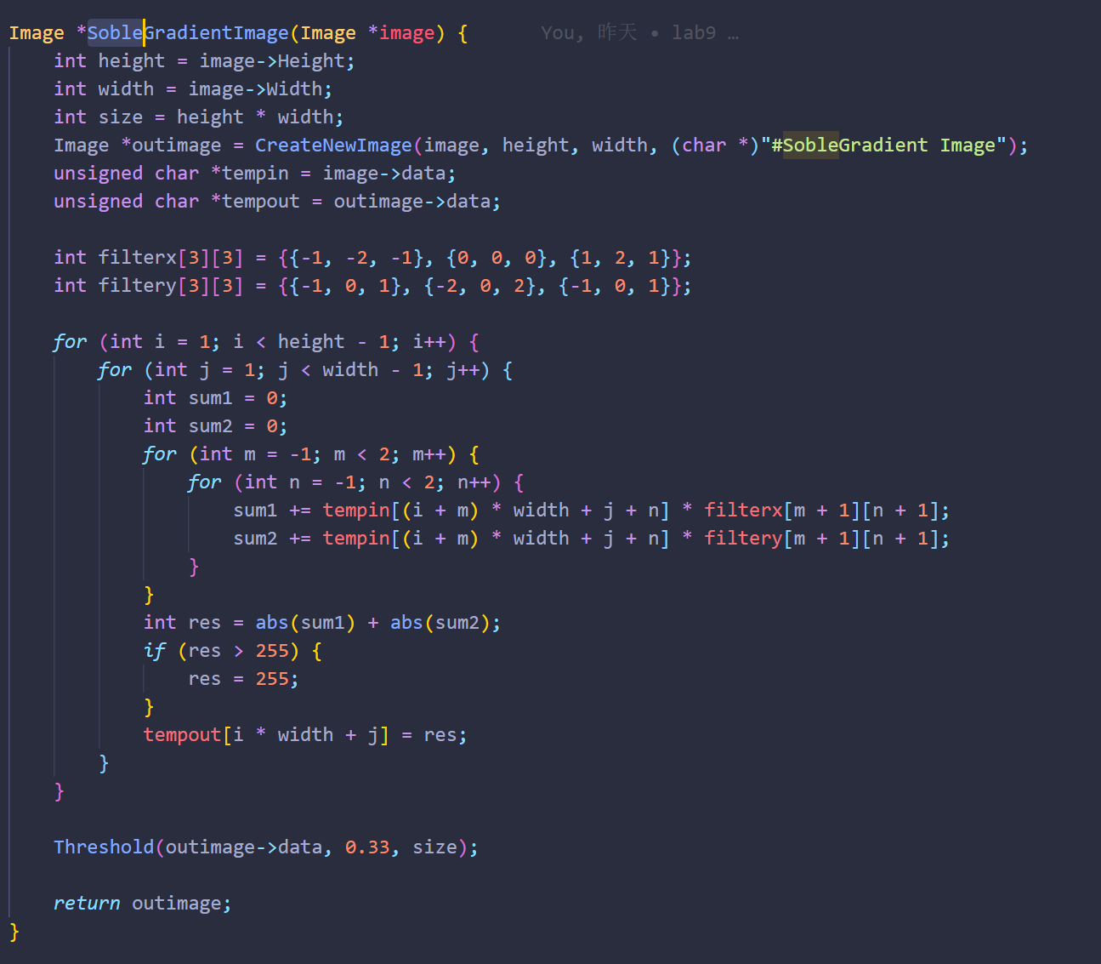

1. **Canny Edge (headCT_Vandy, noisy_fingerprint):**

**Algorithm:**

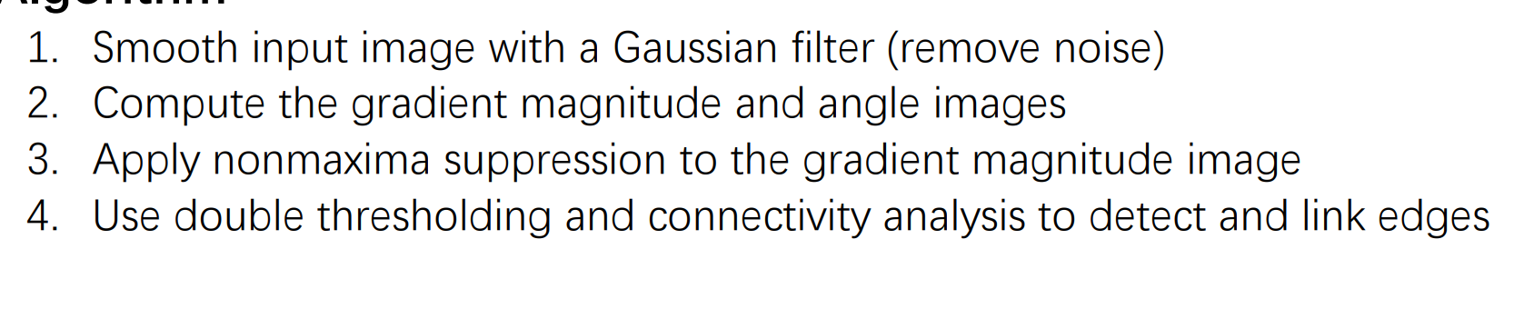

**Results (including pictures):**

Result of processing “headCT_Vandy.pgm”:

Source Image:



Result after Canny:

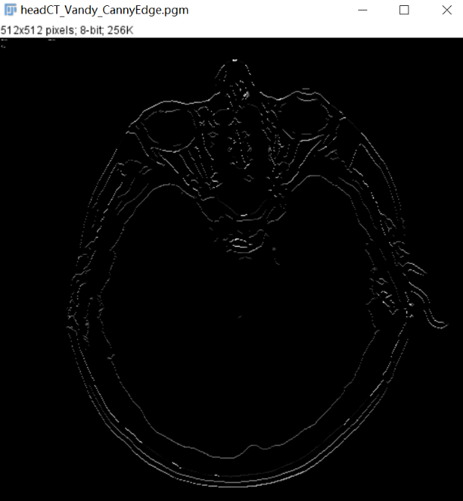

Result of processing “noisy_fingerprint.pgm”:

Source Image:



Result after Canny:

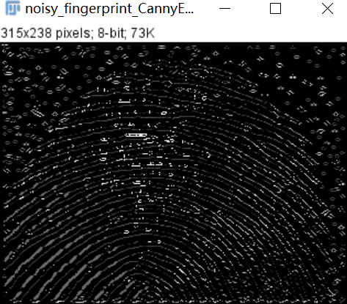

**Discussion:**

The details of the main edges are clearly improved in the Canny results, while more irrelevant features are suppressed. Continuity, fineness and straightness of the lines are also better in the Canny image.

**Codes:**

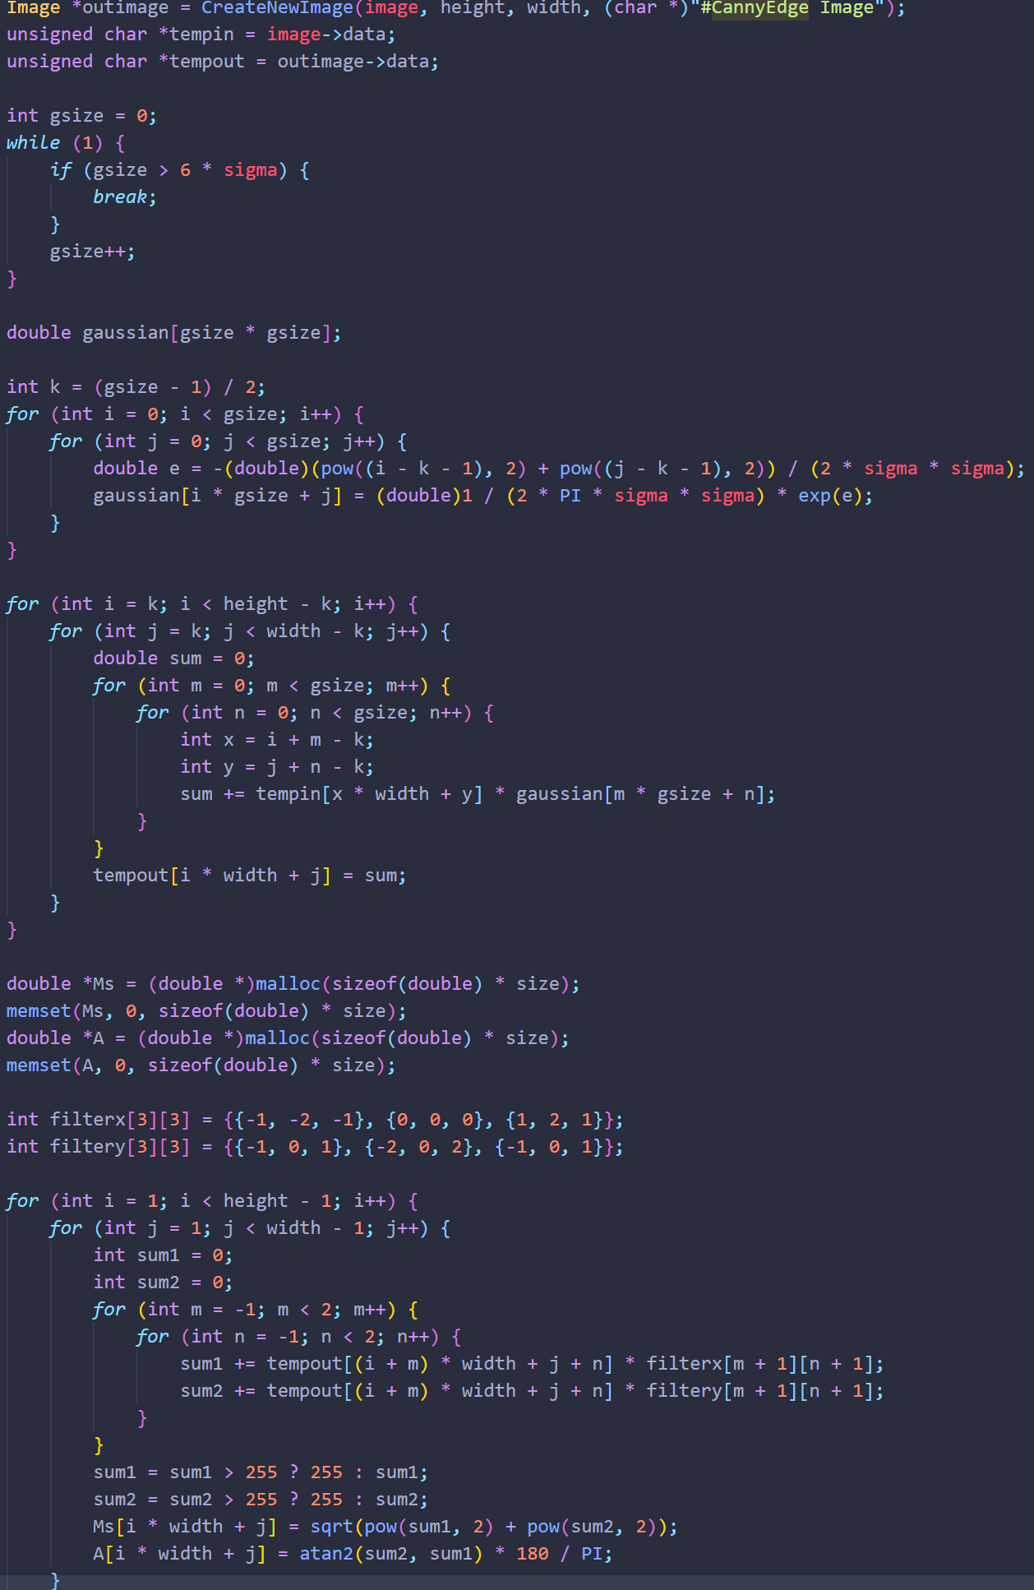

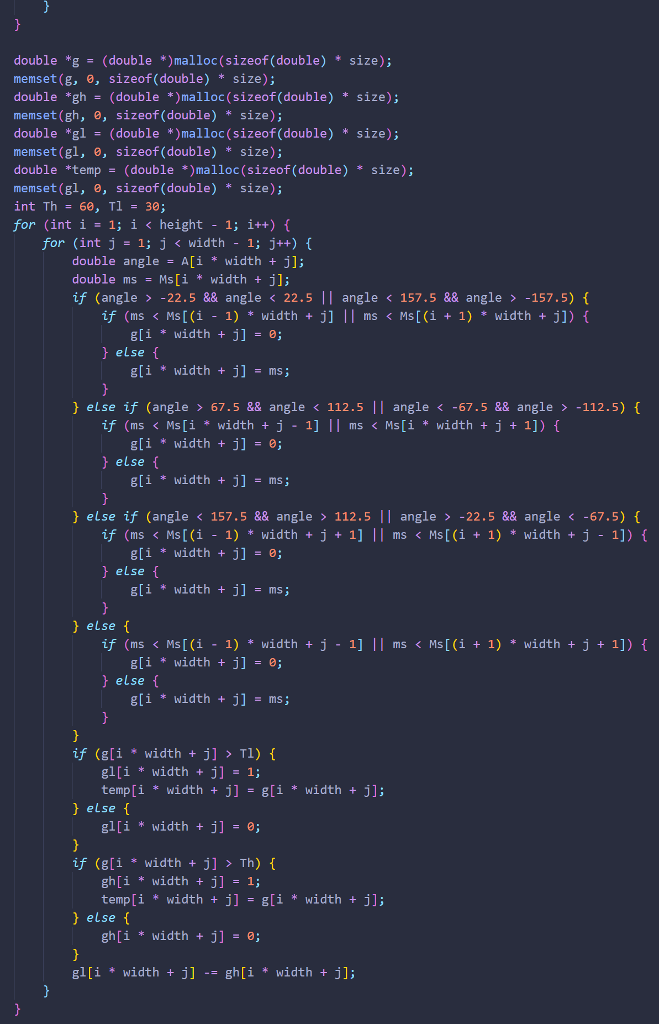

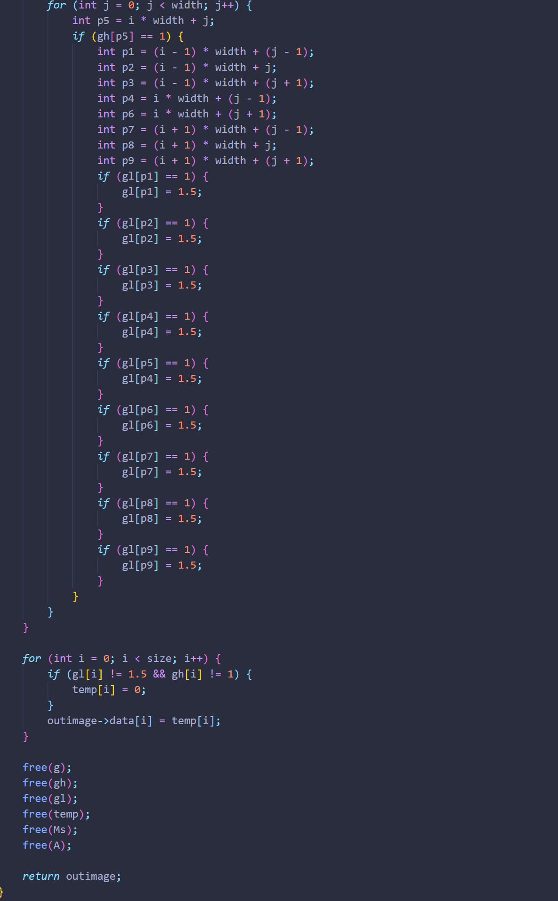

1. **Global Thresholding (polymersomes, noisy_fingerprint):**

**Algorithm:**

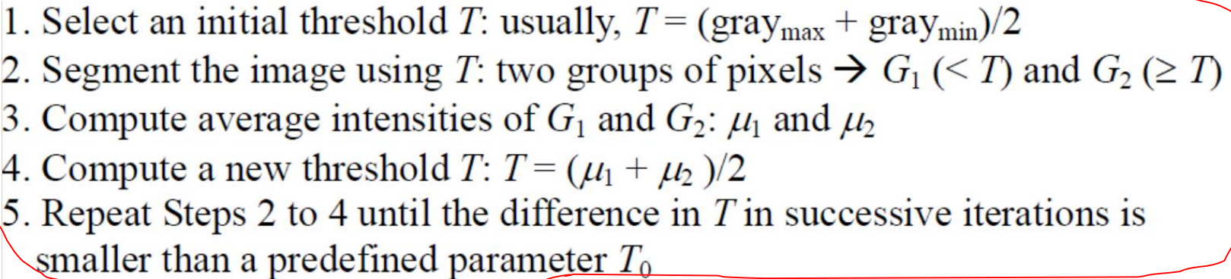

**Results (including pictures):**

Result of processing “polymersomes.pgm”:

Source Image:

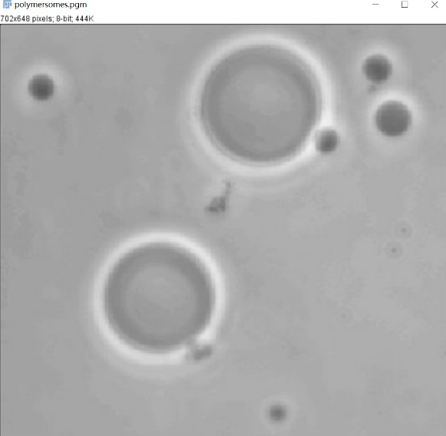

Result after Global:

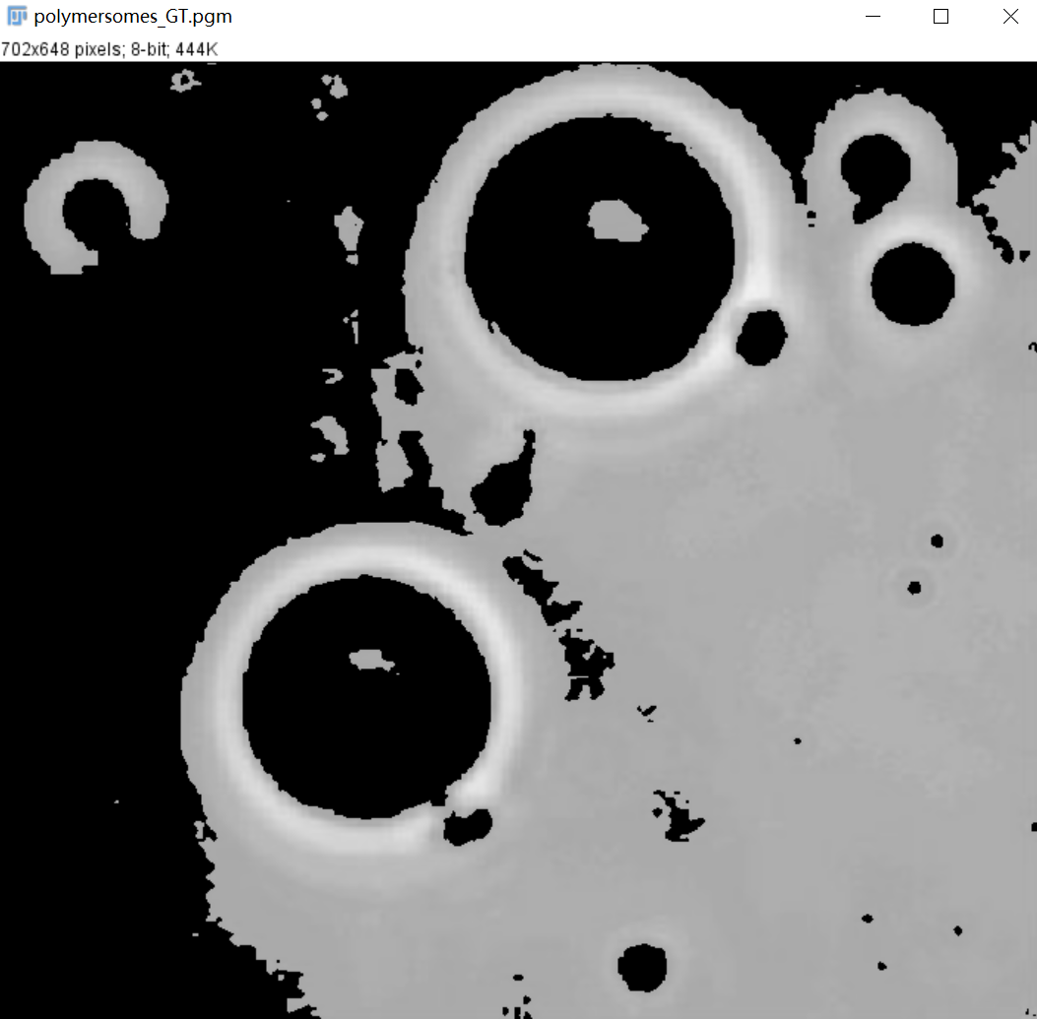

Result of processing “noisy_fingerprint.pgm”:

Source Image:



Result after Global:

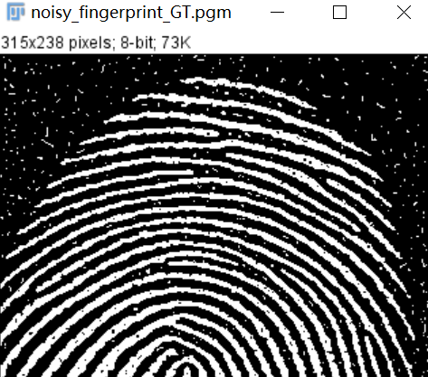

**Discussion:**

Global thresholding is very effective when the grayscale distributions of target and background pixels are very different. But for similar binary images, this thresholding cannot remove noise very well.

**Codes:**

